PERTH MODERN SCHOOL


UNIT 3C/3D MAS – 2010

TEST 4 – POLAR COORDINATES, COMPLEX NUMBERS & PROOFS

NAME: _________________________________________ DATE: _______________

[To achieve full marks and to allow assessment of particular outcomes, working and reasoning should be shown.]
[A maximum of 2 marks will be deducted for incorrect rounding, units, etc.]

This is Resource Free, no calculator allowed – 50 minutes for 40 marks:

Question 1 [ 3 marks ]
Express 1 – i and 1 + 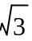i in polar form and hence simplify (1 + i)⁵ ÷ (1 – i)⁴.

Question 2 [ 2 marks ]
Find the exact distance between the points A [6, 25⁰] and B [10, 145⁰]

Question 3 [ 5marks ]
Given z = 3 – 3i indicate on a single Argand Diagram the points representing
- z ⁻¹

- z ²

- iz

d) 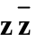

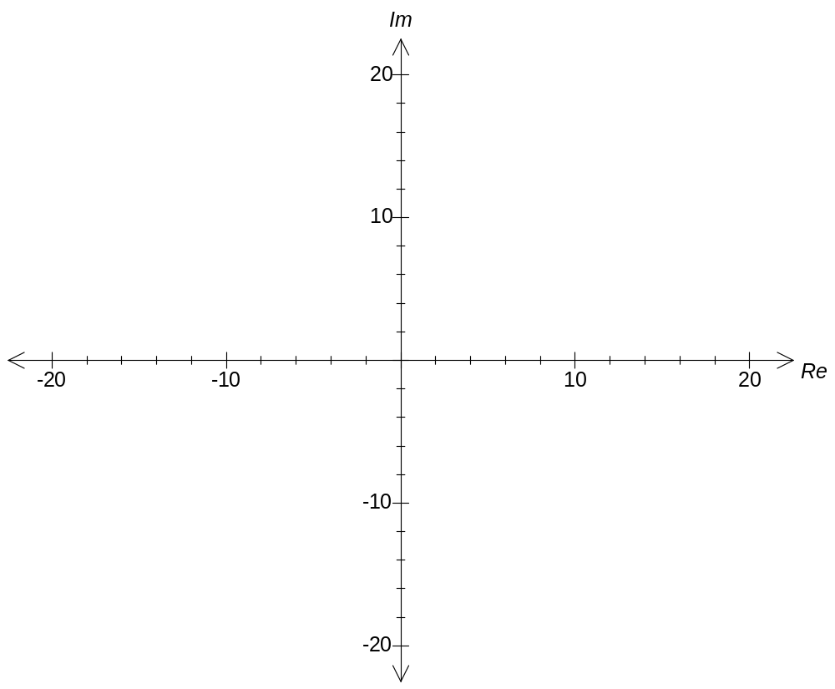
Question 4 [ 2, 3 marks ]
- Express the following in the form (a, b) where (a, b) represents the complex number a + bi:

e^{2 – 0.5πi}

- Using cos θ + i sin θ = e^{iθ} and cos θ - i sin θ = e^{-iθ} obtain an expression for both sin θ and cos θ in terms of e^{iθ} and e^{-iθ}.

Hence prove sin (2θ) = 2 sin θ cos θ.

Question 5 [ 2, 2 marks ]
a) Draw the graph of y = |2x + 1| + |2x – 1|

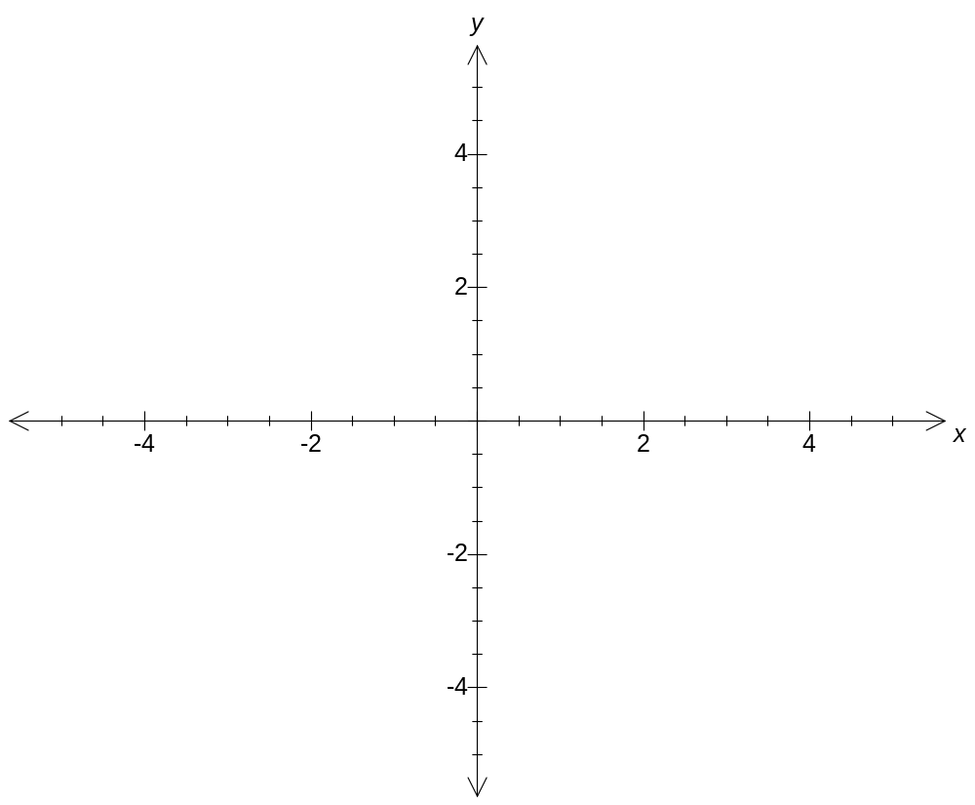

b) Hence, or otherwise, define y as a piecewise function

Question 6 [ 3 marks ]
OABC is a rhombus with 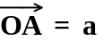 and 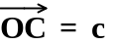.

Use vector methods to prove the diagonals of a rhombus are perpendicular to each other

Question 7 [ 4 marks ]
Prove by exhaustion that for a positive integer n then n(n + 1) (n + 2) is a multiple of 3.

Question 8 [ 2, 2, 2 marks ]
a) Find the set of values for x for which 1 – x > 2|x + 1|.

b) Graph the function y = 1 – x – 2|x + 1|.

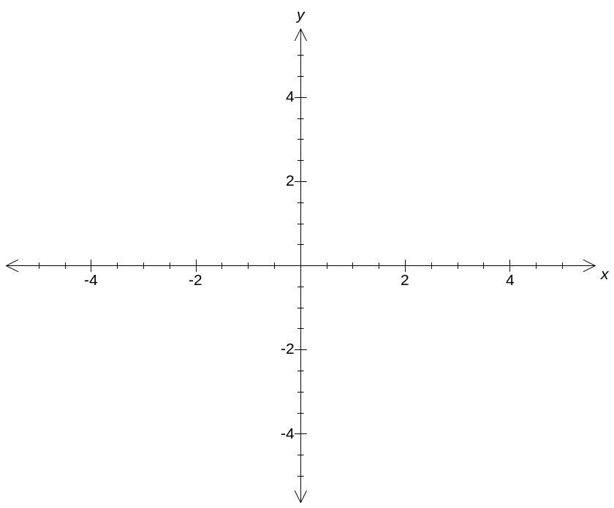

c) Explain how your graph can be used to solve part a).

Question 9 [ 3 marks ]
Determine exact values for all the roots of z³ = -8 + 8 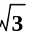i

Question 10 [ 5 marks ]
Find all complex numbers Z satisfying 